МІНІСТЕРСТВО ОСВІТИ І НАУКИ УКРАЇНИ

НАЦІОНАЛЬНИЙ УНІВЕРСИТЕТ «ЛЬВІВСЬКА ПОЛІТЕХНІКА»

Кафедра інформаційних систем і мереж

Лабораторна робота №6

з дисципліни: «Екстремальне програмування»

Ключовий обмін Діффі-Хеллмана

|  |
| --- |
| Виконав:  Студент групи ЕКП-ІСМ-301  Гасій В. Ю.  Прийняв:  Щербак С. С. |

Львів – 2020

**Завдання**

Реалізувати ключовий обмін Діффі-Хеллмана.

**Розв’язання**

Main.cpp

#include "Include.h"

using boost::multiprecision::cpp_int;

cpp_int create_key(const cpp_int &n, int g, const cpp_int &x)

{

return modular_pow(g, x, n);

}

cpp_int create_shared_key(const cpp_int &n, int g, const cpp_int &x_a, cpp_int y_b)

{

return modular_pow(y_b, x_a, n);;

}

int main()

{

std::vector<cpp_int> g;

cpp_int x_a, x_b;

cpp_int y_a, y_b;

int bits;

int t;

cpp_int num;

while (1 > 0)

{

int x;

std::cout << "Enter [1] to create prime number and its first root\nEnter [2] to create your key\nEnter [3] to create shared key\nEnter [4] to exit\n";

std::cin >> x;

switch (x)

{

case 1:

std::cout << "Enter an amount of bits: ";

std::cin >> bits;

num = create_prime_number(bits);

std::cout << "Prime number = " << num << std::endl;

g = initial_roots(num, 1);

std::cout << "g = " << g[0] << std::endl;

std::cout << std::endl << std::endl;

break;

case 2:

std::cout << "Enter a number: ";

std::cin >> num;

std::cout << "Enter its first root: ";

std::cin >> g[0];

x_a = create_number(rand() % ((convert_decimal_to_binary(num).length()) - 2) + 2);

y_a = create_key(num, int(g[0]), x_a);

std::cout << "X = " << x_a << std::endl;

std::cout << "Y = " << y_a << std::endl;

std::cout << std::endl << std::endl;

break;

case 3:

std::cout << "Enter a number: ";

std::cin >> num;

std::cout << "Enter its first root: ";

std::cin >> g[0];

std::cout << "Enter a X: ";

std::cin >> x_a;

std::cout << "Enter a Y: ";

std::cin >> y_b;

std::cout << "Shared key = " << create_shared_key(num, int(g[0]), x_a, y_b) << std::endl;

std::cout << std::endl << std::endl;

break;

case 4:

system("pause");

return 0;

}

}

std::cout << "\n\n";

system("pause");

return 0;

}

Include.h

#pragma once

#include <iostream>

#include <boost/multiprecision/cpp_int.hpp>

#include <vector>

#include "Prime_Number.h"

#include "Initial_Roots.h"

Initial_Roots.h

#pragma once

#include <iostream>

#include <cmath>

#include <boost/multiprecision/cpp_int.hpp>

#include <ctime>

#include <vector>

using boost::multiprecision::cpp_int;

cpp_int euler_function(cpp_int n);

std::vector<cpp_int> initial_roots(cpp_int number, int amount);

Prime_Number.h

#pragma once

#include <iostream>

#include <cmath>

#include <boost/multiprecision/cpp_int.hpp>

#include <ctime>

#include <vector>

using boost::multiprecision::cpp_int;

cpp_int modular_pow(cpp_int base, cpp_int exponent, cpp_int modulus);

cpp_int create_number(int n);

cpp_int convert_binary_to_decimal(cpp_int number);

bool Rabin_Miller(const cpp_int &p, int n , int t );

cpp_int create_prime_number(int n);

bool is_prime(const cpp_int &p, int n , int t );

std::string convert_decimal_to_binary(cpp_int number);

Inirial_Roots.cpp

#include "Initial_Roots.h"

#include "Prime_Number.h"

cpp_int euler_function(cpp_int n)

{

cpp_int result = n;

for (cpp_int i = 2; i * i <= n; i++)

{

if (n % i == 0)

{

while (n % i == 0)

n /= i;

result -= result / i;

}

}

if (n > 1)

result -= result / n;

return result;

}

std::vector<cpp_int> initial_roots(cpp_int number, int amount)

{

std::vector<cpp_int> div;

std::vector<cpp_int> roots;

cpp_int n = euler_function(number);

cpp_int temp = n;

for (int i = 2; i <= n; i++)

{

if (n%i == 0)

{

n /= 2;

div.push_back(i);

i--;

}

}

std::sort(div.begin(), div.end());

div.erase(unique(div.begin(), div.end()), div.end());

n = temp;

cpp_int counter = 2;

while (roots.size() < amount)

{

bool is_root = true;

for (int i = 0; i < div.size(); i++)

{

if (modular_pow(counter, n / div[i], number) == 1)

{

is_root = false;

}

}

if (counter >= number)

{

break;

}

if (is_root)

{

roots.push_back(counter);

}

counter++;

}

return roots;

}

Prime_Number.cpp

#include "Prime_Number.h"

using boost::multiprecision::cpp_int;

std::vector<int> prime_numbers = { 2,3,5,7,11,13,17,19,23,29,31,37,41,43,47,53,59,61,67,71,73,79,83,89,97,101,103,107,109,113,127,131,137,139,149,151,157,163,167,173,179,181,191,193,197,199,211,223,227,229,233,239,241,251,257,263,269,271,277,281,283,293,307,311,313,317,331,337,347,349,353,359,367,373,379,383,389,397,401,409,419,421,431,433,439,443,449,457,461,463,467,479,487,491,499,503,509,521,523,541,547,557,563,569,571,577,587,593,599,601,607,613,617,619,631,641,643,647,653,659,661,673,677,683,691,701,709,719,727,733,739,743,751,757,761,769,773,787,797,809,811,821,823,827,829,839,853,857,859,863,877,881,883,887,907,911,919,929,937,941,947,953,967,971,977,983,991,997,1009,1013,1019,1021,1031,1033,1039,1049,1051,1061,1063,1069,1087,1091,1093,1097,1103,1109,1117,1123,1129,1151,1153,1163,1171,1181,1187,1193,1201,1213,1217,1223,1229,1231,1237,1249,1259,1277,1279,1283,1289,1291,1297,1301,1303,1307,1319,1321,1327,1361,1367,1373,1381,1399,1409,1423,1427,1429,1433,1439,1447,1451,1453,1459,1471,1481,1483,1487,1489,1493,1499,1511,1523,1531,1543,1549,1553,1559,1567,1571,1579,1583,1597,1601,1607,1609,1613,1619,1621,1627,1637,1657,1663,1667,1669,1693,1697,1699,1709,1721,1723,1733,1741,1747,1753,1759,1777,1783,1787,1789,1801,1811,1823,1831,1847,1861,1867,1871,1873,1877,1879,1889,1901,1907,1913,1931,1933,1949,1951,1973,1979,1987,1993,1997,1999 };

cpp_int modular_pow(cpp_int base, cpp_int exponent, cpp_int modulus)

{

cpp_int result = 1;

while (exponent > 0)

{

if (exponent % 2 == 1)

{

result = (result * base) % modulus;

}

exponent = exponent >> 1;

base = (base * base) % modulus;

}

return result;

}

cpp_int create_number(int n)

{

srand(time(NULL));

cpp_int number;

std::string temp = "\0";

temp += "1";

for (int i = 0; i < n - 1; i++)

{

temp += std::to_string(rand() % 2);

}

number = convert_binary_to_decimal(cpp_int(temp));

return number;

}

cpp_int convert_binary_to_decimal(cpp_int number)

{

cpp_int decimalNumber = 0, remainder;

int i = 0;

while (number != 0)

{

remainder = number % 10;

number /= 10;

decimalNumber += remainder * cpp_int(pow(2, i));

++i;

}

return decimalNumber;

}

bool Rabin_Miller(const cpp_int &p, int n = 0, int t = 0)

{

int b = 1;

while ((p - 1) % cpp_int(pow(2, b)) == 0)

{

b++;

}

b -= 1;

cpp_int m = (p - 1) / cpp_int(pow(2, b));

cpp_int a;

cpp_int z;

srand(time(NULL));

for (int i = 0; i < t; i++)

{

a = create_number(rand() % (n - 2) + 2);

z = modular_pow(a, m, p);

if (z == 1 || z == (p - 1))

{

continue;

}

for (int j = 0; j < b - 1; j++)

{

z = modular_pow(z, 2, p);

if (z == 1)

{

return false;

}

if (z == (p - 1))

{

break;

}

}

if (b == i && z != (p - 1))

{

return false;

}

}

return true;

}

cpp_int create_prime_number(int n)

{

int t = 5;

cpp_int number;

std::string temp="\0";

do

{

number = create_number(n);

temp = convert_decimal_to_binary(number);

temp = temp.substr(0, temp.size() - 1);

temp += "1";

number = convert_binary_to_decimal(cpp_int(temp));

} while (!is_prime(number, n, t));

return number;

}

bool is_prime(const cpp_int &p, int n = 0, int t = 0)

{

for (int i = 0; i < prime_numbers.size(); i++)

{

if (p == prime_numbers[i])

{

return true;

}

if (p%prime_numbers[i] == 0)

{

return false;

}

}

if (Rabin_Miller(p, n, t))

{

return true;

}

return false;

}

std::string convert_decimal_to_binary(cpp_int number)

{

std::string binaryNumber = "\0";

int remainder;

while (number != 0)

{

remainder = int(number % 2);

number /= 2;

binaryNumber = std::to_string(remainder) + binaryNumber;

}

return binaryNumber;

}

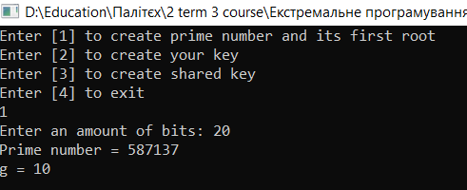

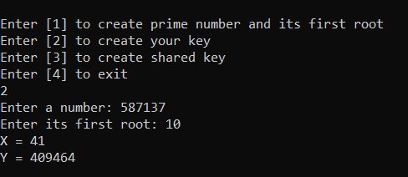

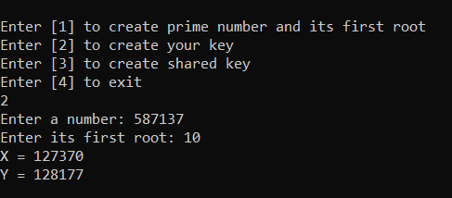

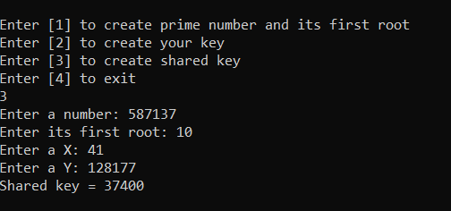

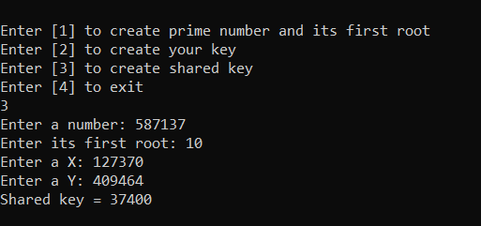

**Висновок**: на цій лабораторній роботі було реалізовано ключовий обмін Діффі-Хеллмана.